PROJECT REPORT

Name:Seshadrinathan K

Roll no.: 22f3001117

Email: 22f3001117[@ds.study.iitm.ac.in](mailto:23f1001651@ds.study.iitm.ac.in)

**Description:**

This is Hello, an influencer sponsor engagement application that I created for the course Modern Application Development-I. This goal of this application was to create a seamless environment where a company or an individual can create campaigns and launch ad requests which can be received or approached by influencers. This application was created with Jinja templates, styled with basic CSS and with Flask as the backend and SQLAlchemy as the database.

**Database Design**:

Each sponsor can create multiple campaigns, and each campaign can have multiple ads.An ad can be associated with only one campaign. An influencer can request for many campaigns and many ad campaigns. There is a messaging feature provided for each ad, and each ad can have multiple messages, but a message can be associated with only one ad request.

### **Relationships:**

1. **User to Campaign: One to Many**
2. **Campaign to Ad Request: One to Many**
3. **Ad request to Messages: One to Many**

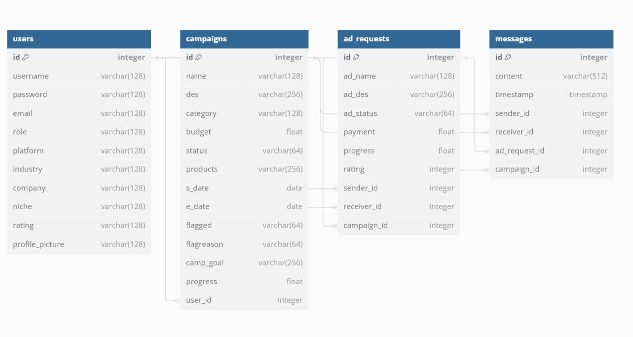

**Features:**

1. **Landing Page:**
   * There is an aesthetic landing page which then redirects the user to three different pages, login, influencer signup and sponsor signup depending on what the need is
2. **Login:**
   * Depending on the type of signup, the login is modifiable. The admin, Influencers and sponsors can register in the same signup page
   * Login for the admin is embedded in the code
3. **Campaign Management:**
   * Sponsors can create campaigns and request ads from influencers.
   * The sponsor can search for Influencers and vice versa, the influencer can search and sort for different campaigns
   * Influencers can submit ad requests to any campaign. Once accepted, the influencer can update progress or message regarding the progress(for general chat purposes, the messages are available)
   * Sponsors can view the progress of campaigns and individual ads and message the influencers regarding the progress.
   * Sponsors will be permitted to update any detail of a campaign after it has been created.
4. **Ads:**
   * When an ad request from a sponsor is accepted by an influencer (or vice versa), an entry is created between the sponsor and the influencer.
   * After an ad is accepted, the sponsor can proceed with payment for the service.
   * Both sponsors and influencers can retract their respective ad requests before they are accepted by the other party. If the ad is already accepted, it cannot be deleted.
   * Influencers can update the progress of their ads.
5. **Admin:**
   * The admin has the ability to view all influencers and sponsors within the application.
   * The admin can flag any campaign on suspicion.
   * The admin can also view all campaigns created by sponsors
   * Admin can also view all the influencers
   * Additionally, the admin can monitor the progress of a campaign through the stats page

**Video**:

Link: https://drive.google.com/drive/folders/1Zvyihe26Uqw1fXUR0z3IrE7RdZf7uHae?usp=drive_link